 **Department of Electronics and Communication Engineering**

**Shavige Malleshwara Hills, Kumaraswamy Layout, Bengaluru – 560 078.**

**(An Autonomous Institute affiliated to VTU, Approved by AICTE)**

PROGRAM: B.E

BRANCH: Electronics & Communications

COURSE: Analog Electronics & Linear IC’s applications SEMESTER: 3B

COURSE CODE: 22EC32

A Report on

**IR detector circuit using 555 timer**

Submitted by:

**1DS22EC098 - Kaushik K C**

**1DS22EC120 - Manish S**

**Diploma - Shivamadu D N**

Faculty In-charge:

**Dr. DRUVA KUMAR S**

Signature of faculty in-charge

**AIM:**To design and simulate a IR detector circuit using 555 timer

**MULTISIM APPARATUS:**

1. 555 Timer IC
2. IR Transmitter
3. IR Receiver
4. BC547 transistor
5. BC557 transistor
6. 10 uF/25V Capacitor
7. Led
8. Resistor (1 KΩ, 10 KΩ, 22 KΩ, 220Ω)
9. Piezo Buzzer

10. Switch

11.9v Battery

**CIRCUIT DIAGRAM:**

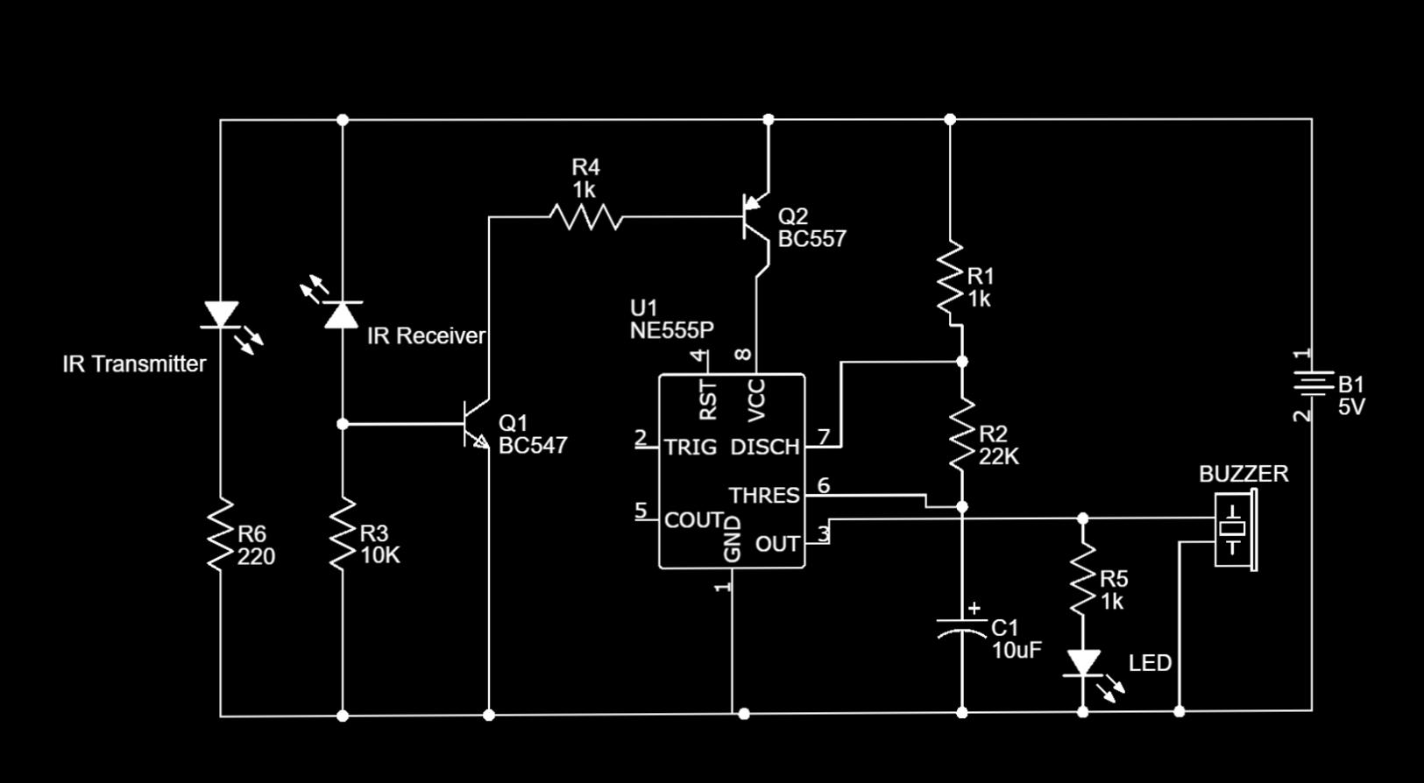

**THEORY:**

In this tutorial, We will create an IR sensor by using IC 555 Timer with simple steps. The operation of this IR sensor is so simple when an object is in front of the sensor, led will light up. We have two IR LEDs, a transmitter and a receiver. When the current passes through the transmitter led, it will emit IR rays. We can see these IR rays by using any mobile or any other camera device.

The receiver is used in reverse bias and is used to capture IR rays. The cathode(-) of the LED is connected to the source (+) terminal. Being in reverse bias, the receiver will allow, in its initial state a small current to pass through it. When an IR ray falls on the receiver, it will allow a higher current to pass through it. Here we will use a 555 Timer IC.

**Circuit Connection:**

In this IR sensor project, we will put the IC 555 timer IC on the breadboard. And then we should connect pin 8 to the collector of the BC557 transistor and pin 1 to the ground. Next, the base of BC557 is connected to the collector of the BC547 transistor through a 1 KΩ resistor. Another terminal of BC557 i.e., the emitter is directly connected to Vcc.

The base of the BC547 is connected between the cathode of the IR receiver and a 10 KΩ resistor. And another emitter part is connected directly to the ground.

Next, Pin 7 of the IC is connected between a 1 KΩ and a 22 KΩ resistor and it is connected with pin 6 through this 22 KΩ resistor.

Pin 6 and pin 2 are connected with each other and a 10uF capacitor from pin 6 is connected to the ground.

Finally, the IR receiver is connected to the base terminal of BC547 with its cathode terminal this terminal is also connected to the ground through a 10 KΩ resistor. Its anode terminal is connected to Vcc.

The IR transmitter is connected with Vcc with its cathode terminal and the anode terminal is connected to the ground through a 220 Ω resistor.

The output from pin 3 of the IC is connected to a buzzer and another terminal of the buzzer is grounded.

**Working principle of IR Sensor:**

In the above IR sensor circuit diagram, we should note that transistor BC547 is an NPN transistor and transistor BC557 is a PNP transistor. BC547 will be in an active mood when a positive voltage is applied to its base and the BC557 will be in an active mood when a negative voltage is applied to its base.

When the whole circuit is turned on, the IR transmitter starts emitting infrared rays, which fall on the IR receiver and a potential difference will create across the IR receiver which turns on the transistor BC547, which further turns on the transistor BC557 through the collector and base. Then the transistor BC557 starts to conduct Vcc supply to pin 8 of the 555 timer IC which turns on the 555 timer IC.

In this IR sensor project, the 555 timer IC is configured in astable mode. The output from pin 3 by turning on the circuit which is shown by a buzzer is activated for a particular frequency. This frequency of the buzzer’s beeping can be determined by the given formula

Output Frequency = 1.44/(R1+2*R2)*C1

Where R1 represents the resistor between pin 7 and pin 8 i.e., 1 KΩ resistor and R2 represents the resistor between pin 6 and pin 7 i.e., 22 KΩ resistors. C1 represents the capacitor between pin 6 and the ground of the 555 timers IC i.e., 10 uF.

**ADVANTAGES:**

* Cost-Effective
* Simplicity
* Versatility
* Low Power Consumption
* Adjustability

**APPLICATIONS:**

* Use the IR sensor to detect the presence of an object or person within a certain range. The sensor’s output can trigger an action, such as turning on lights or activating a security system.
* Implement the sensor for detecting specific objects based on their reflective or absorptive properties in the infrared spectrum. This can be useful in automated sorting systems or object recognition projects.
* Incorporate the IR sensor into a line-following robot to detect and follow lines on a surface. The changes in reflection from the surface can be used to control the robot’s movement.
* Integrate the IR sensor into a security system to detect movement or intrusion. When the sensor is triggered, it can activate an alarm or notify the user of a potential security breach.
* Employ the IR sensor to sense human presence in a room. This information can be used to automate lighting, climate control, or other smart home features based on occupancy.

**CONCLUSION:**

The DIY IR sensor with a 555 timer offers a cost-effective and versatile solution for various projects. Its simplicity, adjustability, and educational value make it an ideal choice for beginners exploring electronics. While suitable for many applications, consideration of specific project requirements is essential.

**RESULTS:**

The experiment successfully achieved its objectives by thoroughly examining the IR detector circuit using 555 timers.